Course Title: Network Auditing and Control

Course prerequisite(s): 1003460 | Course code: 1003461
Credit hours: 3 | Course Level:
Semester/Lecture Time:

Instructor Details

Instructor Name | e-mail | Office Hours

Course Description

This course highlights the threats that face the exchanging of data electronically through computer networks. Also, gives the student the tools to overcome theses threats. The course also explains the OSI Network Security Model. The course materials are tailored such that the student can get hands on and get training in writing different cryptographic algorithms using C/C++ language.

Objectives

At completing this course the student will be familiar with:
1. Computer Network Security Architecture.
2. Computer Network Security Tools.
3. Computer Network Security Threats.
Also the student should be able to write different cryptographic Algorithms Using C/Cpp and/or
Visual Basic

Learning outcomes:
At the end of the course the student should acquire the following learning outcomes:
A - Knowledge and Understanding:
1- To show the ability to demonstrate different aspects of e-mail and network security.
2- To show the ability to evaluate mathematical expressions using Modular arithmetic and
Galois Field Arithmetic.
3- To show the ability to encrypt “PlainText” into “CipherText” and vice versa, using different
encryption algorithms.
4- To have the ability to design and implement a security application using C++/VB programming language.
B - Intellectual Skills:
1- The ability to choose a suitable ciphering algorithm according to the required security level.
2- The ability to understand a given ciphering algorithm and to analyze it.
3- The ability to setup any programming language and use it fast and effectively during
homework and the final project.
4- Practice self-learning by using the e-courses and web materials
C - Practical Skills:
1- The ability to understand the final project requirement.
2- The ability to use the library, Web sites, references during his/her final project preparation.
3- The ability to use computer in fulfillment of the final project.
4- The ability to handle the project output results, fitting them into curves or into charts.
5- The ability to find the conclusion from these results and comment on it.
6- The ability to present his/her works in an academic and scientific way, and write his/her
report according to official format from the department.
D - Transferable Skills:
1- Show the ability to rely on him/her self as well as to participate in a team work.
2- Display personal responsibility by working to multiple deadlines.
3- Show the ability to use library, the text book and other references.

Course Contents:
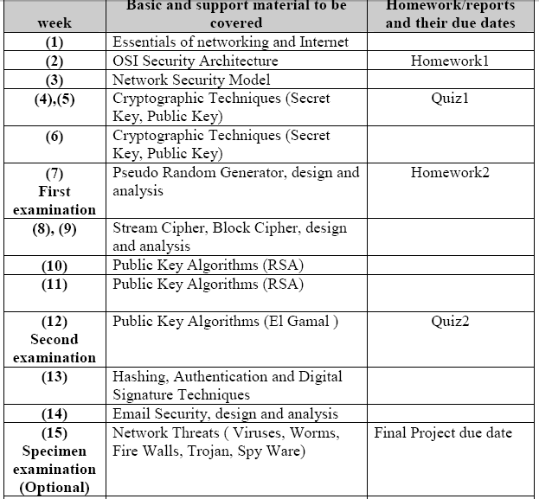
Assessment and Grade Distribution

Assessment |  | Requirements | Points | Total
Assignment and Projects |  |  |  | 20%
Project , lab, Presentation & Discussion |  |  | 10%
Attendance, Participation, Home works, and Quizzes |  | Chapter Homework, Discussions, Short Presentations  Unannounced Short quizes | 10%
Individual Work |  |  |  | Unannounced Short quizes
First Exam |  | . | 20%
Second Exam |  |  | 20%
A Comprehensive Final examination |  |  | 40%
TOTAL |  |  |  | 100%

Teaching and Learning Methods:

Course format:
New material will be presented in lectures. Homework will be due on time before class; this will give me time to review them before class, to direct discussions. Fine answers to difficult questions will earn the student a chance to present the solution to the class.
Each class (except the first) will begin with a review of the homework from the week before (with presentations, when applicable), followed by presentation of new material.

Policies:
- You are responsible for all the material covered in lectures, readings and homework's.
- Class attendance is very important. I will take attendance at all of them. Those who miss 3 classes may be dropped a full letter grade; those missing 6 or more receive a failing grade.
- Class participation is important. I encourage questions. Please don't be afraid to ask questions during a lecture, as this often means that many people may have a similar question, and it is worth stopping me.
References and Books:
- 1. Richard E. Smith, “Internet Cryptography”, Wesley, 1997.
- 2. A. Menezes, “Handbook of Applied Cryptography”, CRC Press, 1996.
- 3. Charles P. Pfleeger, “Security in Computing”, Prentice-Hall, 2002.
- 4. Merike Kaeo, "Designing Network Security ", Indiana, Cisco Press 2004.

